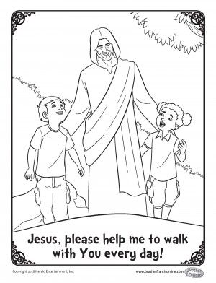

Draw or write about the ways you can walk with Jesus.

Your Name: