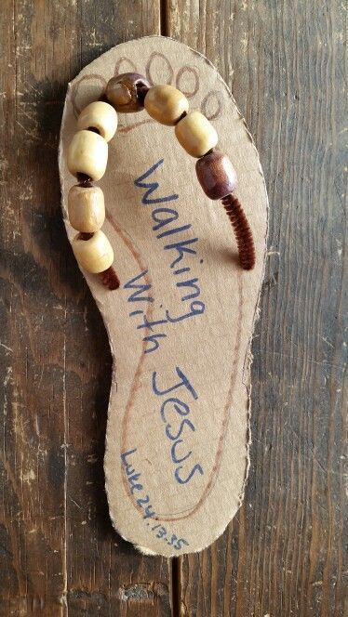

So do not

fear, for I

am with you;  
do not be dismayed, for I

am your God.

Isaiah 41:10a

Use the template below to trace and cut the base of the sandal. Use wire, pipe cleaners or paper for the straps. Write a message on the shoe to remind you that Jesus is walking beside you or cut and paste Isaiah 41:10a onto the shoe.

Hang the show where is can be seen by the whole family as you head outside for a walk!

