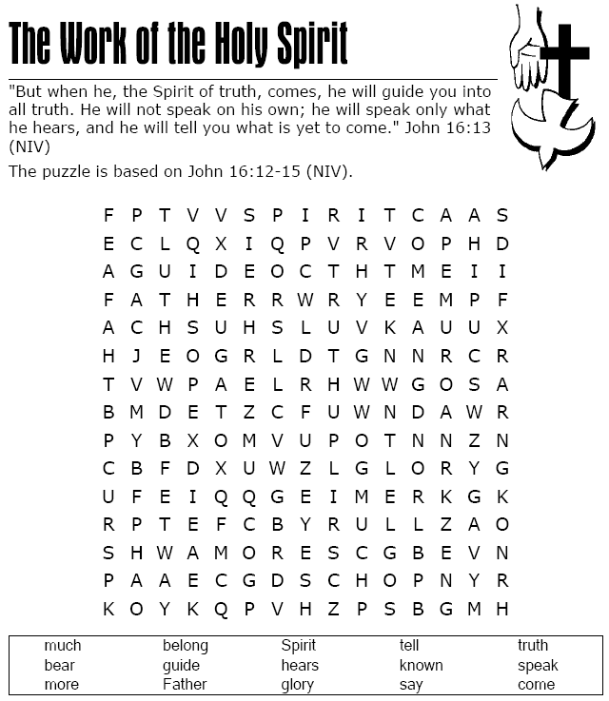



Printable bookmarks. Color and give one or both away to someone as a reminder of God’s love for them.

I am a child of God



I am a child of God

