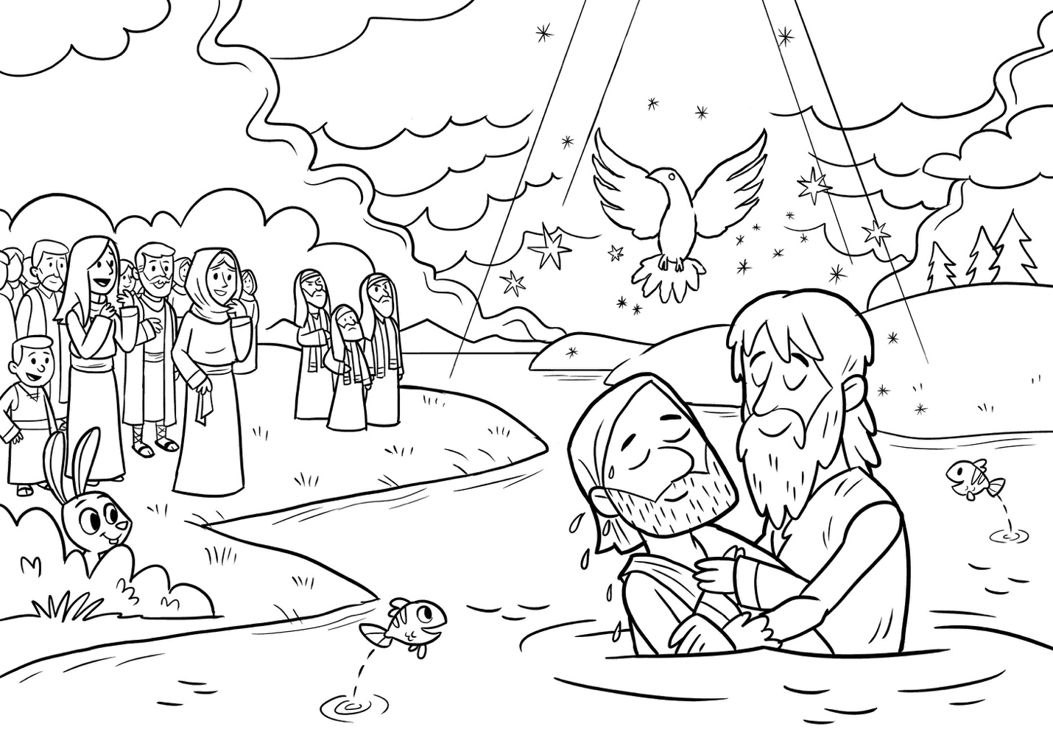

Behold, the Lamb of God, who takes away the sin of the world! John 1:29b

