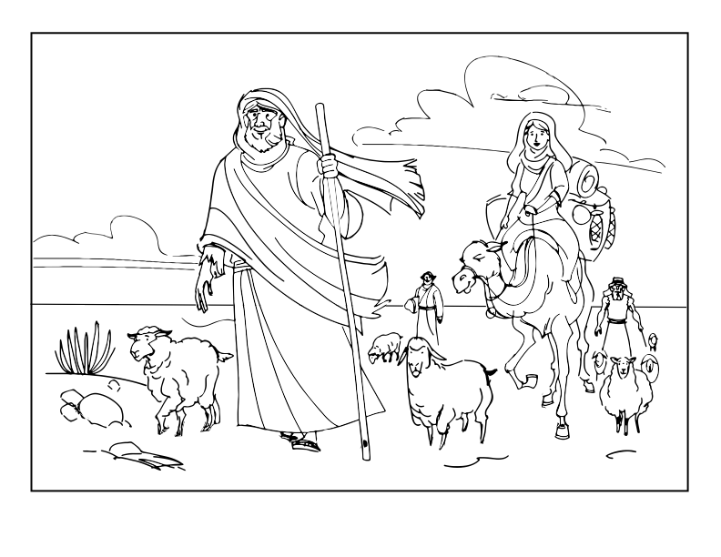
God guided Abraham.
Copyright © 2014 www.SundaySchoolZone.com. All Rights Reserved. Free to duplicate for church or home use. Visit http://SundaySchoolZone.com

